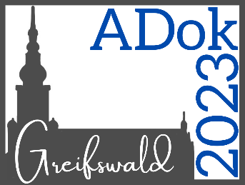
Registration for the
12th ADok in Greifswald
— June 22nd to June 24th, 2023
Please fill out this form by May 15th, 2023 and send it to us via e-mail: adok23@uni-greifswald.de
Please answer every question in this form so that we are able to process your registration.
Also, please note that you can only withdraw your registration until May 22nd, 2023 without being charged the registration fee.

Personal Information
Last name  First name  E-Mail address  University/Institution  Address | Klicken oder tippen Sie hier, um Text einzugeben.  Klicken oder tippen Sie hier, um Text einzugeben.  Klicken oder tippen Sie hier, um Text einzugeben.  Klicken oder tippen Sie hier, um Text einzugeben.  Klicken oder tippen Sie hier, um Text einzugeben.

Contribution
What kind of contribution are you planning to make?
Please note that we may have to change the contribution type if too many contributions of one type are registered.
☐ Poster | ☐ Talk | ☐ attendance without contribution

If you would like to contribute
Title
Klicken oder tippen Sie hier, um Text einzugeben.
Author(s), affiliation
Klicken oder tippen Sie hier, um Text einzugeben.
Abstract (300 words)
Klicken oder tippen Sie hier, um Text einzugeben.
Keywords (up to four)
Klicken oder tippen Sie hier, um Text einzugeben.

Social Events
Would you like to participate in the Pre-Conference Workshop on Thursday, June 22nd (“Projects in R: Creating Reproducible Analyses”)?
☐ yes | ☐ no

Are you planning to participate in the BBQ on Saturday evening (price included in registration fee)?
☐ yes | ☐ no

Do you have any dietary preferences?
☐ vegan | ☐ vegetarian | ☐ no

